**StylerZone Test - 11, Nov 2018**

**Priority 1:**

**Team:**

Form Look.

Button is not showing.

**Profile Page:**

-Social media icons are not working fine.

-Contact us for is not working fine. Taking too much time to send email and no spinner/message to wait.

- Wrong spell of ‘Review’ in heading “Good Or Bad - It’s Still A Reivew”

**Priority 2:**

**Register Page:**

1. Remove checkbox of “Terms & Conditions” and change text to “By clicking Register Account button you agree to our [Terms and Conditions](http://staging.stylerzone.com.au/termsandconditions), including our Cookie use ”.
2. Change text of button ‘Register account’ to “Register Account”.

**Confirm Email Popup:**

* Cross button should not show.
* Resend Email button color and effects should like standard button in website.

**Account/Dashboard:**

Business name should show as heading with profile link below header image.

-**Business Information**:

1. Wrong Tap order.
2. Address Field should optional field.
3. By clicking Lookup ABN button showing wrong message.
4. System is allowing to save data without check “**I agree that all provided details are correct**”, which is wrong.
5. Address looks like required field with red starik ‘*’ but still can update info without it. Make it optional by removing starik ‘*’.

**Account Setting:**

Add a field of old password.

Change update password field name to New Password.

**Payment Method:** No option is checked as in below image but still showing on profile page.  
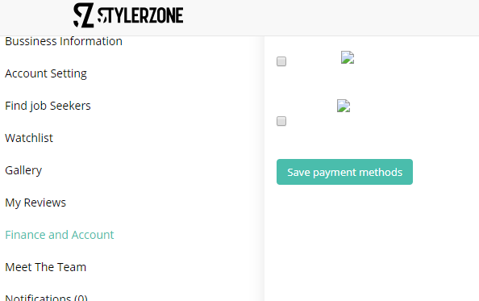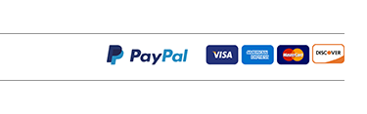

**Listing:**

Add listing buttons effects are not standard.

**Profile Page:**

Slider images are stretching.

Lot of bugs on console.

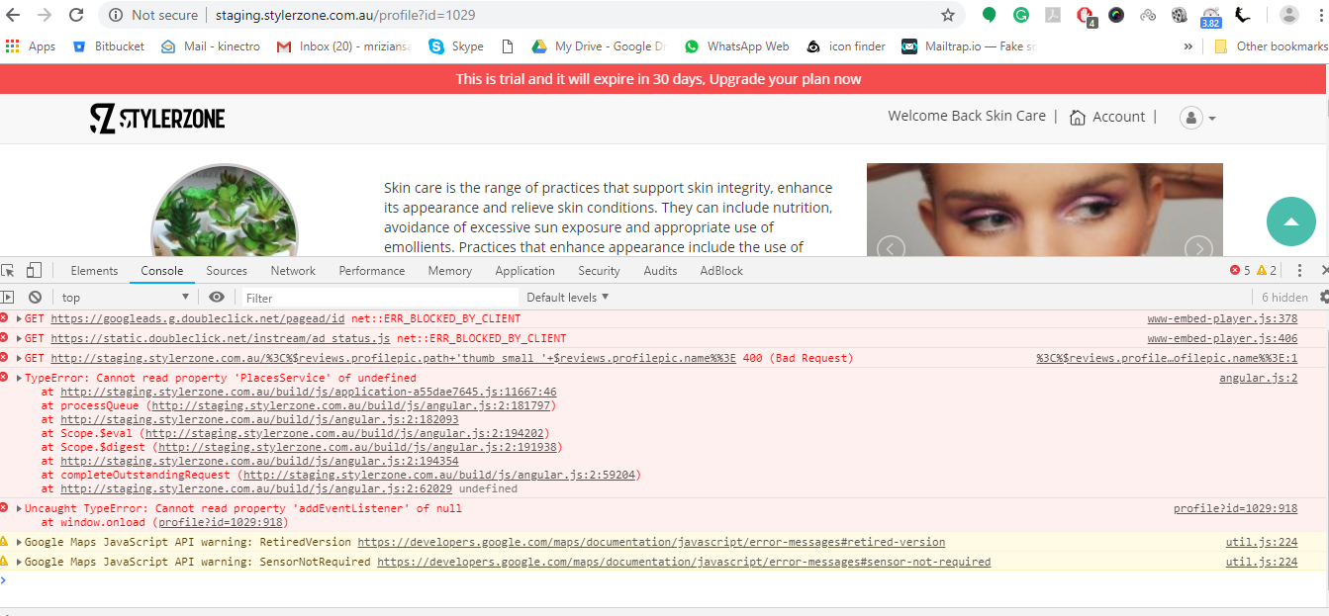

-Should not show reviews heading “Good Or Bad - It’s Still A Review” if there is no review. Or add a Big text “No Review Yet” if there is no review.

- By clicking **“View More”** button i can see 1 deal while i have not added any deal yet.

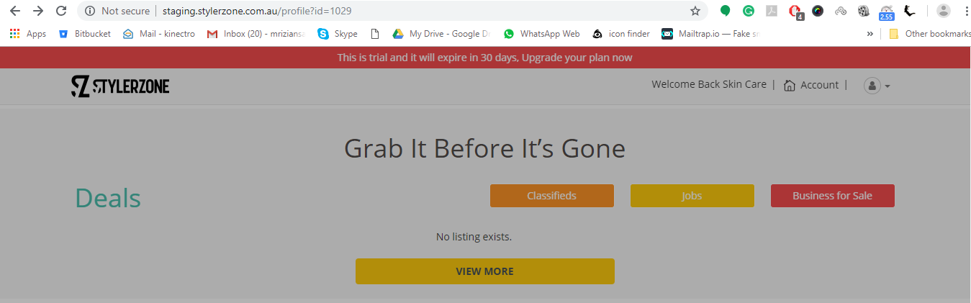

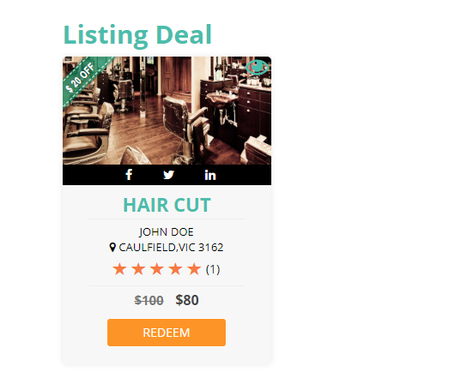

**Booking Page:**

Timing is not showing mints.

**Listing:**

**Classified:**

1. Location field ‘L’ character should large.
2. Expiry Date should disable.
3. Images upload showing wrong.

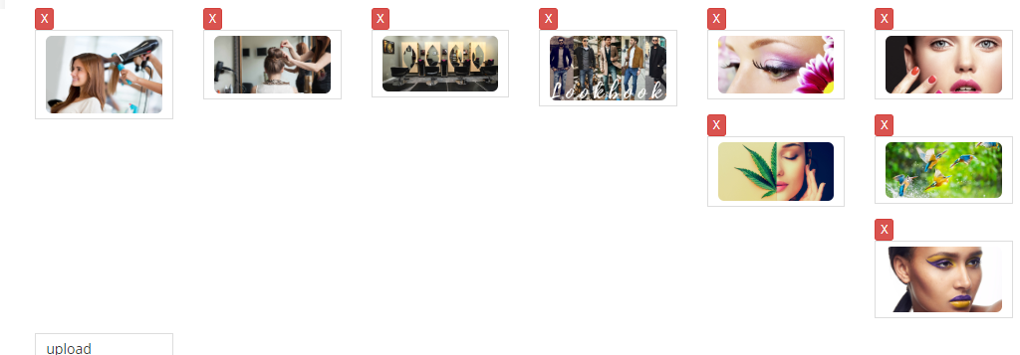

-Success popup is not showing on save.

-I have to refresh listing page to view new added listing.

**StylerBook**

Change Favicon to stylerbook icon. Color Green

**Login Page:**

Change Logo to StylerBook logo.

Change text “Enter User Name” to “Enter Email” in first field as we are not saving username.

**Add Service:**

1. Tab wrong arrange.
2. Checkbox alignment.
3. Below Image

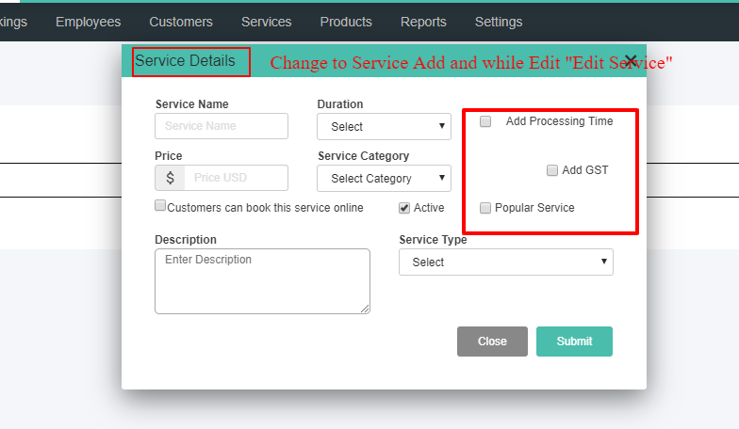

**Category:**

Category list color should under color hading. Now it’s right align.

